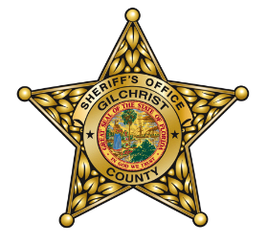
Gilchrist County Sheriff’s Office is hosting a
Concealed Carry Weapons Course
To be held at the
Gilchrist County Sheriff’s Office Firing Range
(Located behind the Gilchrist County Agriculture Complex off US 129 North of Trenton)

Saturday April 16, 2016 8:00 a.m – 2:00 p.m.
Class limited to 20 participants

Cost: $50 donation. Proceeds will go to the THS Softball Diamond Club.

You must be a U.S. resident 21 years of age or older and of good character. The Concealed Carry Permit Course will fulfill the requirements for obtaining a Florida Concealed Weapons Permit. A certificate of course completion and State CWP application packet will be provided after successful completion of the class.

The CCW Class includes the following:

- 3 hours of instruction
- 3 hours of range time
- All shooting accessories (targets, eye and ear protection, etc.)

Bring your own handgun to use for qualifying at the range along with 50-100 rounds of ammunition.

Certified GCSO Law Enforcement Instructors will teach the course.

If you have any questions, please contact Sgt. Leonard Knuckles at lknuckles@gcso.us.

__________________________________________________________________________________________________

Registration Form

Please make $50 Check or Money Order payable to the Lady Tiger Diamond Club.

Name:

Address:

Phone:

Mail or bring Registration Form to: Gilchrist County Sheriff’s Office
9239 S US Hwy 129
Trenton, FL 32693

You can also email Registration Form to lknuckles@gcso.us.

