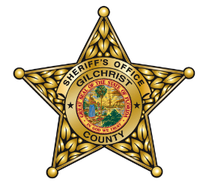
Gilchrist County Sheriff’s Office is hosting a
Concealed Carry Weapons Course
To be held at the
Gilchrist County Sheriff’s Office Firing Range
4052 South US Hwy 129, Bell, FL 32619

Saturday April 2, 2016 8:00 a.m – 2:00 p.m.
Class limited to 20 participants

Cost: $50 donation to the Florida Sheriff’s Youth Ranches

You must be a U.S. resident 21 years of age or older and of good character. The Concealed Carry Permit Course will fulfill the requirements for obtaining a Florida Concealed Weapons Permit. A certificate of course completion and State CWP application packet will be provided after successful completion of the class.

The CCW Class includes the following:

- 3 hours of instruction
- 3 hours of range time
- All shooting accessories (targets, eye and ear protection, etc.)

Bring your own handgun to use for qualifying at the range along with 25-50 rounds of ammunition.

Certified GCSO Law Enforcement Instructors will teach the course.

If you have any questions, please contact Sgt. Leonard Knuckles at lknuckles@gcso.us or 352-222-2568.

__________________________________________________________________________________________________

Registration Form

Please make $50 Check or Money Order payable to the Florida Sheriff’s Youth Ranches

Name:

Address:

Phone:

Mail or bring Registration Form to: Gilchrist County Sheriff’s Office
9239 S US Hwy 129
Trenton, FL 32693

You can also email Registration Form to lknuckles@gcso.us.

